ROYAL CANADIAN LEGION BR. 148

30 Raglan Street South. Renfrew, Ontario K7V 1P7
Office: (613) 432-6450 Clubroom: (613) 432-2582
http://www.renfrewlegionbr148.ca E-mail rclrenfrew@cogeco.net

DECEMBER 2023 / JANUARY 2024
BRANCH BULLETIN

Legion Mission Statement
Our mission is to serve Veterans, including serving Military and RCMP members and their families, to promote Remembrance, and to serve our communities and our country.

MEETINGS:
Branch 148 Executive Meeting 2nd Monday of each Month 7:00 p.m.
Ladies Auxiliary Br 148 Meeting 3rd Tuesday of each Month 7:00 p.m.
Branch General Meeting 4th Wednesday of each Month 7:00 p.m.
The Branch does not have General Meetings during the months of July, August, and December.

UPCOMING DATES

Friday December 8 – Open Mic Night, 7-10pm, in the Lounge
Friday December 22 – Fun Darts Night, Blind Draw Doubles
Friday December 22 – Open Mic Night, 7-10pm, in the Lounge
Monday January 1 – Annual New Year’s Levee, in the Hall
Friday January 5 – Open Mic Night, 7-10pm, in the Lounge
Saturday January 6 – LA Pancake breakfast - pancakes, sausages, juice. tea & coffee for $10.00
Friday January 19 – Open Mic Night, 7-10pm, in the Lounge
Saturday January 27 – Ray Megrath Memorial Dart Tournament
Mondays | Legion Seniors Darts have started and are every Monday afternoon at 1pm – come out for an afternoon of fun and friendship!
Tuesdays | Foot Care Clinic, twice a month
Thursday Afternoons | In conjunction with Community Living Renfrew County South, we are having a drop-in pool afternoon, every Thursday from 1-2:30. Pool is free during this time, and the Lounge will be open. Please join us for fun and comradeship.
Friday afternoons | Please join us for our weekly meat draws, starting around 3pm in the Lounge. Tickets are $2/draw, and there are 5 draws: Breakfast Box, Beef Box, Metro Card, Pork & Chicken Box, and an LCBO Card.
Fridays | Open Mic nights are back at the Legion! Our December dates are Friday, December 8, and Friday December 22. Please join us in the Lounge from 7-10pm for some great local entertainment – all skill levels are welcome!
Saturdays | Weekly entertainment - please check our Facebook page or our website, listen to Valley Heritage Radio Coming Events, or call the Branch for more information

MESSAGE FROM THE PRESIDENT: Comrades: Winter is almost here. It’s time to pull out the warm parkas, boots and toques. It’s time to crank up the furnace to keep the house warm and cozy. Speaking of furnaces, for those who are unaware, our Branch had to replace both furnaces this year to the tune of $30,000.00. We are still looking for donations to help defray the cost to the Branch. So, if you would like to make a Christmas gift to the “Furnace Fund” it would be greatly appreciated. In other news, 2024 is going to be an exciting year for the Branch. We will be celebrating the 95th Anniversary of our Charter, as well as the 80th Anniversary of D-Day. On March 10, we will begin our celebrations by hosting the Zone Convention. On June 6, I am hoping to have a full-blown celebration for D-Day with a parade to the Cenotaph and wreath laying ceremony, followed by a banquet at the Branch. Hopefully throughout the year there will be many other festivities planned. Wishing you and your families a blessed Christmas and a healthy and prosperous 2024. Please keep safe and enjoy the festive season. Comrade Bruce Ferguson, President

FROM THE OFFICE: We are continuing with our Furnace Fund, and If you wish to donate towards this, we are accepting donations, or if you have any ideas for a fundraiser, please contact the office (613-432-6450).

LAST POST: Our Deepest sympathy is expressed to the family of Ordinary Member/WW2 Veteran Comrade Cecil Code. If you hear of a member passing away, please contact the office and let the Secretary know so that we can be sure to include them in the next bulletin.

"They shall grow not old, as we that are left grow old.
Age shall not weary them, nor the years condemn.
At the going down of the sun and in the morning
We will Remember Them."

If anyone knows of any local senior veterans who are not Legion members, please let the office know.

GREETINGS TO OUR HOUSEBOUND MEMBERS: A warm hello to all of our members who are unable to visit the Branch:
Bonnechere Manor: Louise Snow, Gerald Coules Arnprior Villa: Ben Kane

If you know of someone who should be included, please contact the office and let the Secretary know so that we can be sure to include them in the next bulletin.

PROPERTY: Our hot water tank had to be replaced. The lights in the kitchen will be fixed soon – waiting for Yemen’s to make arrangements. Richard Fitzsimmons, Property Co-Chair

SPORTS: Zone sports dates are now confirmed: Zone 8-ball, December 3, 2023 at Br 550 Cobden; Zone Cribbage, December 9, 2023 at Br. 406 Barry’s Bay; Zone Seniors Darts, December 17, 2023 at Br. 148 Renfrew; and Zone Darts, January 6, 2024 at Br. 436 Deep River. We will be holding a Fun Darts night, Blind Draw Doubles on Friday December 22, 2023. Registration is from 6pm to 6:45, with play at 7pm. Registration fee is $15.00/person. Come out and enjoy a fun night of darts, and meet some new people. Greg Walbeck, Sports Chair

ENTERTAINMENT: The entertainment in the Lounge is being enjoyed by a number of people every Saturday afternoon, 4-8pm. For December, the following bands are booked: Dec. 2 – Rick King; Dec. 9 – Jerry Lee; Dec. 16 – Smooth Country; Dec. 23 – Silas; Dec. 30 – no band, due to levee January 1. The Levee this year will be Rick King and his band, and there is a cover charge of $5.00 (to help offset the cost of the band). As the holiday season approaches, I would like to wish everyone a safe and happy holiday. Brian Snider, Entertainment Chair

OPEN MIC NIGHTS: Open Mic Nights have been booked for December & January. The dates are December 8 and 22, and January 5 and 19, from 7-10pm in the Lounge. Stop by the Lounge on the second Friday of the month, for some great local entertainment. We are always welcoming anyone who sings, plays an instrument or who just wants to have fun.
Joel McCrea, Open Mic Coordinator

1ST RENFREW SCOUTS: We were successful with our Apple Day this year, thanks to everyone who supported us. A big thank you to No Frills for suppling the apples. The following week all the youth made applesauce and got to take some home, it was very tasty. The youth were happy to support the Poppy Campaign by helping with Poppy Tagging and serving the Remembrance Day Dinner. We will be participating in the Santa Claus parade and are working on our float. For our Christmas Party we will visit one of our leaders home and have a campfire. We can't wait for the smores the youth make and don't want. Will see what adventures we can do in the New Year. We are wishing everyone a Merry Christmas and Happy New Year. Yours in Scouting, Susan Fleming

LADIES’ AUXILIARY: We are slow this year but having fun with the few catering requests we have. It was fun working with a couple of RCI students, Calabogie Girl Guides and 1st Renfrew Scouting during the Remembrance Day Dinner. Thanks for everyone's support and helping out. In December we will be having our Christmas potluck meeting again when the awards will be handed out. Mark your calendars January 6 we will be hosting a pancake breakfast. Included will be pancakes, sausages, juice. tea and coffee for $10.00. Next one will be February 3. We are so proud of Comrades Laura Warren, Sheila Riopelle, Lianne Lariviere, Cathy Buzzell and Rose LaFont who participated in Ladies Auxiliary District Single and Double Darts in Kingston. They all went out and had fun. Comrade Laura place 2nd in Singles. We would like to wish everyone a Merry Christmas and a safe and happy 2024 from our homes to yours. Susan Fleming, LA President

HONOURS AND AWARDS: Congratulations to our Legionnaire of the year Kelly Berger and all those who received pins, medals and bars. Have a safe and happy holiday.
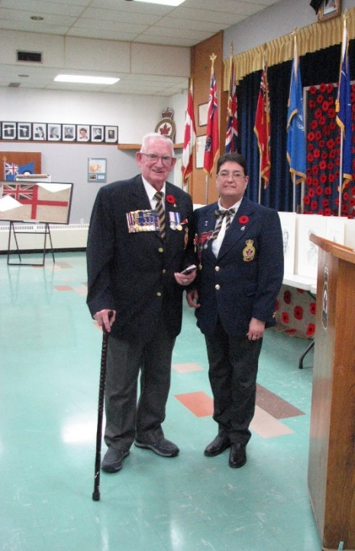 | At the Nov. 11 Remembrance Day Dinner, Branch Honours & Awards Chair Comrade Rose LaFont presents the 50 year membership medal to Comrade Gary Murphy.
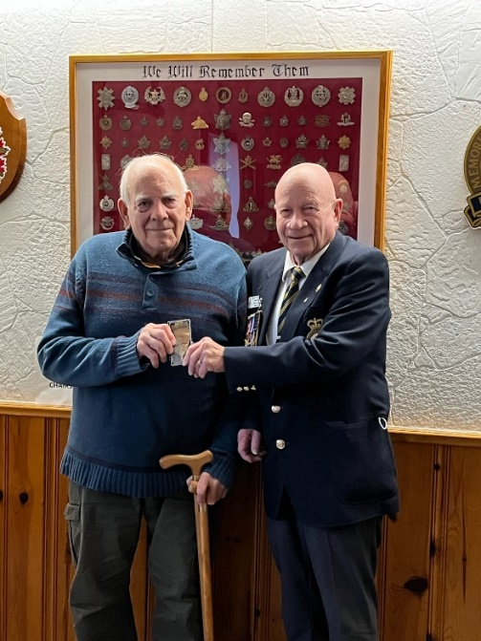 | President Comrade Rev. Bruce Ferguson presents the 50 year membership medal to Comrade William Mason.
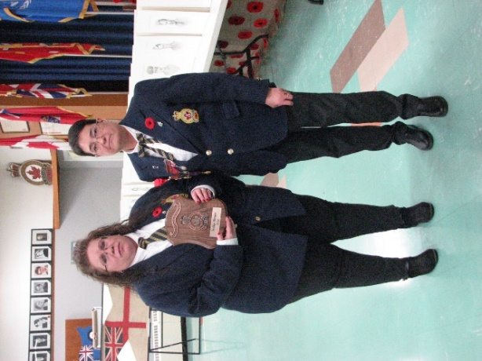 | Also at the Nov. 11 Remembrance Day dinner, Honours & Awards Chair Comrade Rose LaFont presents the Legionnaire of the Year Award to Comrade Kelly Berger, at the Nov. 11 Remembance Day dinner.
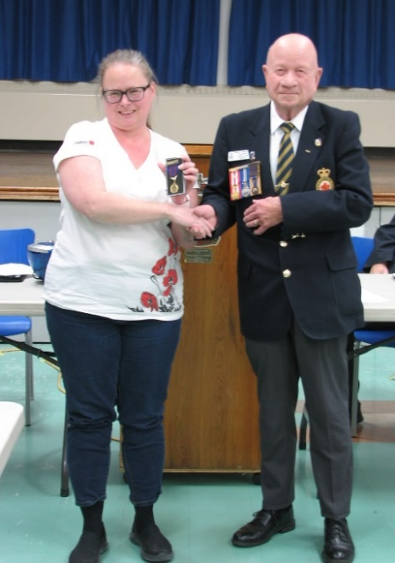 | At the Nov. 22 General Meeting, Comrade President Rev. Bruce Ferguson awarded the Branch Service Medal to our Secretary/Treasurer, Comrade Jessica Thompson.
Rose LaFont, Honours & Awards Chair

CHAPLAIN’S MESSAGE: There are so many details that surround the celebration of Christmas that it is easy to miss the actual meaning. Christmas is not about the parties, the presents or the poinsettias. It’s not about the food, the festivities, or even about family. It’s not the greenery or the garland; not the Christmas cards, credit cards, or carols; not about tinsel or traditions. The fact is this: Christmas is solely about God. Christmas is about God fulfilling his promises, saving his people, coming to us – as one of us – in Jesus. The truth can be so easily missed: Christmas is nothing but Jesus. And if Jesus is not in Christmas, then Christmas is nothing at all. I wish you and your families a happy and holy Christmas season. Although the commercial celebration of Christmas started even before Thanksgiving, the Christmas season extends until January 10 with the Baptism of the Lord. Don’t be in a hurry to take down the Christmas decorations too soon! Even though we’ve endured some tough challenges in the Branch this year, there have also been many blessings for which I thank God. Most especially, I thank God for the countless hours many of you have put in, in keeping the Branch alive during this year. May God bless you for your goodness! May the message of Christmas motivate all of us to seek ways to make peace, not war. May we be stimulated to accept others who may seem different from us, rather than sit and complain about those strangers. May we initiate a smile toward one another, and not a frown. May we do this every day in 2024.
Rev. Bruce Ferguson, Chaplain

MEMBERSHIP: With this year coming to an end, I would like to once again welcome all new members and transfers from other branches to Branch 148. With no general meetings until January, I would like to wish everyone a very Merry Christmas and a happy and safe new year. Our next General meeting will be the 24th of January and I’m hoping all new members can make it for a Welcoming ceremony. We will see you in 2024. Robert Marsh, Membership Chair

LEGION SENIORS: I want to wish everyone a Very Merry Christmas and a Happy New Year. Senior darts are going very well. We have 10 to 14 players each week. As December 25 (Christmas Day) and January 1 (New Years Day) both fall on a Monday, therefore no darts. Darts will resume on January 8, 2024. Tena Miller, Legion Seniors

LEADERSHIP AND DEVELOPMENT: As a Legion member, you should think about registering for MemberPerks (https://legion.ca/member-login/memberperks).

This will give you discounts for travel, hotels, restaurants, and many other services. It is free to sign-up. Once you have signed up, you will receive lots of offers for discounts. You can also log into the Legion MemberPerks site: https://legion.venngo.com/login. On the site you can explore all different offers and discounts available to you. Kelly Berger, Leadership & Development

BURSARY: Ontario Command Bursary program is intendent to assist students for a maximum of 5 years provided they continue in the same subject of study. Students must complete a new application each academic year. Members please help to get the word out that theses bursaries’ are available to qualifying students in the amount of $1,250.00 The responsibly for a completed application is that of the student. All applications must be mailed to Ontario Command. Ella Box, Bursary Chair

CHARITABLE FOUNDATION: The Ontario Command Branches and Ladies Auxiliaries Charitable Foundation, a registered Charity, is a partnership of the Branches of the Royal Canadian Legion and Auxiliaries in Ontario Command Foundation funds are used to support programs such as the provincial bursaries, medical equipment, medical research and programs for aging veterans. This program is open to fund medical equipment for hospitals, not-for-profit homes, Hospices, Fire Stations. District G has representation on the Foundation Board. Renfrew Branch donated $2,000.00 to assist this program. Deadline for applications is April 26, 2024. Submitted by Ella Box

WAYS & MEANS: I am looking for volunteers to assist with the weekly Friday Meat Draws, and with Saturday 50/50 draws in the Lounge. If you would like to help with selling tickets, please contact me by email at joan.mcnulty@icloud.com, or call the office and leave your name and number.
Joanie McNulty, Ways & Means

NEVADA: Nevada sales very slow, and I hope thing improve in new year. I would like to wish everyone a very Merry Christmas and a Happy New Year. Ron Kilby, Nevada Chair

MILITARY SERVICE RECOGNITION BOOK: We received 23 books Volume #10, and copies were delivered to all schools in the Renfrew area, Long Term Care Homes and Renfrew Library. Copies were also given to the families that had a Veterans submission in this volume. Command is now accepting submissions for Volume 11. This program relies on us as members for timely submissions with individual photos and personal stories of veterans. Submissions are only to contain a maximum of 200 words and not pages of documentation. An original photo is the best option; however an original photo that has been reproduced at a photo lab such as Walmart is acceptable,
Ella Box Coordinator, 613-432-6049

PUBLIC RELATIONS: Did you Know?

- 2023 marks the 75th anniversary of the first United Nations peacekeeping mission. On December 10, 1988, the Nobel Peace Prize was awarded to United Nations Peacekeeping Forces because “the peacekeeping forces of the United Nations have, under extremely difficult conditions, contributed to reducing tensions where an armistice has been negotiated but a peace treaty has yet to be established”. (from the Royal Canadian Legion “Dispatch”)

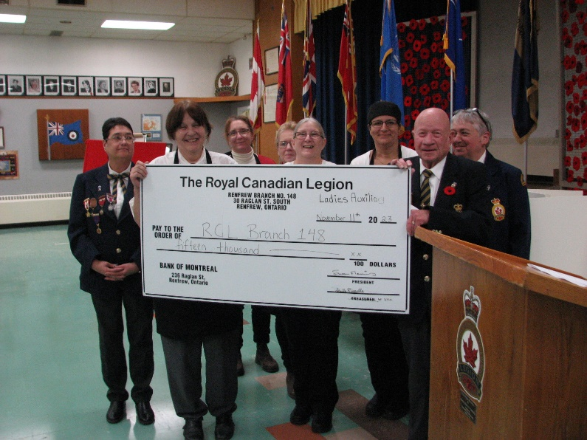 | We would also like to thank our Ladies’ Auxiliary for their very kind donation to the Branch, of $15,000.00!

We are always looking for volunteers to assist at the Branch, for barbecues, meals, selling tickets, etc. It is only an hour or two of your time. Please contact the office at 613-432-6450 to let us know you are able to assist. If you know of any high-school students looking for volunteer hours, please let us know by contacting the office.

Please keep our monthly calendars handy for information, and feel free to review our Facebook page (Royal Canadian Legion Br. 148 Renfrew) or our website (www.renfrewlegionbr148.ca) for current information. If you have an email address, please provide it to the Office so that you may be added to our email lists. Debbie McDermid, PRO

 | December 2023
Sun | Mon | Tue | Wed | Thu | Fri | Sat
 |  |  |  |  | 1  Lounge: Meat Draw, 3pm  Hall Reserved: Dart Tournament | 2  Hall Reserved: Vendor Craft Sale  Entertainment: Rick King,4-8pm
3 INTERNATIONAL DAY OF PERSONS WITH DISABILITIES  Hall Reserved: Christmas Party  Youth Darts, 1:30 | 4  Seniors’ Darts, 1pm | 5 INTERNATIONAL VOLUNTEER DAY  Foot Clinic  Hall: Cornhole League | 6 HALIFAX EXPLOSION (1917)  NATIONAL DAY OF REMEMBRANCE AND ACTION ON VIOLENCE AGAINST WOMEN | 7  Hall Reserved: Community Living Christmas Party  Weekly Pool with Community Living | 8  Lounge: Meat Draw, 3pm  Lounge: Open Mic, 7-10pm  Hall Reserved: Dart Tournament | 9  Hall Reserved: Christmas Party  Entertainment: Jerry Lee,4-8pm
10 NOBEL PRIXE FOR PEACE AWARDED TO PEACEKEEPERS (1988)  Hall Reserved: Christmas Party  Youth Darts, 1:30 | 11  Seniors’ Darts, 1pm  Hall Reserved: RVHA Christmas Party  Executive Meeting, 7pm | 12  Blood Donor Clinic  Hall: Cornhole League | 13 | 14  Weekly Pool with Community Living | 15  Lounge: Meat Draw, 3pm  Hall Reserved: Dart Tournament | 16  Hall Reserved: Christmas Party  Entertainment: Smooth Country,4-8pm
17  Hall Reserved: Zone Seniors Darts  Youth Darts, 1:30 | 18  Seniors’ Darts, 1pm | 19  LA Christmas Potluck/Meeting, 5pm  Hall: Cornhole League | 20 | 21  Weekly Pool with Community Living | 22  Lounge: Meat Draw, 3pm  Open Mic, 7-10pm  Hall Reserved: Fun Darts Night | 23  Hall Reserved: Christmas Party  Entertainment: Silas,4-8pm
24 | 25 FALL OF HONG KONG (1941)  CHRISTMAS DAY – BRANCH CLOSED | 26  BOXING DAY – BRANCH CLOSED | 27 | 28 | 29 | 30  Hall Reserved: Stag & Doe  No Entertainment this weekend, due to Levee
31 | HAVE YOU RENEWED FOR 2024?

 | January 2024
Sun | Mon | Tue | Wed | Thu | Fri | Sat
 | 1 NEW YEARS DAY  Hall: New Year’s Levee, 2-6pm Entertainment by Rick King  $5 cover charge | 2  Hall: Cornhole League | 3 | 4  Weekly Pool with Community Living | 5  Lounge: Meat Draw, 3pm  Lounge: Open Mic, 7-10pm | 6  Hall Reserved: LA Pancake Breakfast 8:30-11:30  Entertainment: Musical Jam Session, 3-7pm
7 | 8  Seniors’ Darts, 1pm  Executive Meeting, 7pm | 9  Foot Clinic  Hall: Cornhole League | 10 | 11  Weekly Pool with Community Living | 12  Lounge: Meat Draw, 3pm | 13  Entertainment: D-Tours, 3-7pm
14 | 15  Seniors’ Darts, 1pm | 16  LA Meeting, 7pm  Hall: Cornhole League | 17 | 18  Weekly Pool with Community Living | 19  Lounge: Meat Draw, 3pm  Lounge: Open Mic, 7-10pm | 20  Hall Reserved: Christmas Party  Entertainment: Pitch Black,3-7pm
21 | 22  Seniors’ Darts, 1pm | 23  Foot Clinic  Hall: Cornhole League | 24 BELL LET’S TALK DAY FOR MENTAL HEALTH  General Meeting, 7pm | 25  Weekly Pool with Community Living | 26  Lounge: Meat Draw, 3pm | 27 HOLOCAUST REMEMBRANCE DAY  Hall Reserved: Ray Megrath Memorial Dart Tournament  Entertainment: Lonesome Dreamers,3-7pm
28 | 29  Seniors’ Darts, 1pm | 30  Hall: Cornhole League | 31 | HAVE YOU RENEWED FOR 2024?

